SharePoint Implementation Underground Technical Services
Novento, Fransiscus, PT Freeport Indonesia, Indonesia

Abstract
Underground Technical Services at Underground division PT Freeport Indonesia is a new Department covering Survey, QAQC, Ventilation, Capital, and Contract Group. SharePoint has been implemented for document management and Collaboration tools among groups’ member. People, Process and Tools was identified in the first beginning of the implementation and continue with socialization and training for groups’ member. The result was significant since all the data are centralized on the SharePoint server for further analysis and reporting. This paper will describe all processes that being transferred to SharePoint for efficiencies and effectiveness of the organization.

Introduction
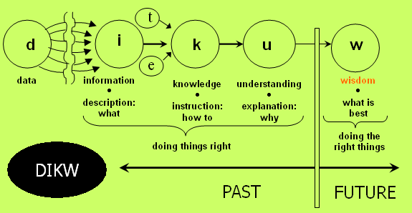
SharePoint from Microsoft has been evolved from WSS 2.0, WSS 3.0, and the latest one is SharePoint 2010. SharePoint 2010 offer more features, e.g. dashboard reporting, excel services, etc. then WSS 3.0 (Windows SharePoint Services), however WSS 3.0 is the engine that drive SharePoint 2010. The SharePoint implementation for Underground Technical Services use WSS 3.0 as a part of Windows Server installation. For detail about installation and features, feel free to go to Microsoft website.
According to DIKW Theory, Data Information and Knowledge Wisdom comes together in a sequences. Knowledge, Information and Wisdom are nothing without data. As a result Data need to be presented in structure and timely manner. Data or Information such as templates, emails, schedules, proposals, forms, budgets, contact information, status reports, regulatory compliance and even ad hoc documents are typically manage by combination of two things:
- Local / personal storage
  - Information is stored in an individual’s personal computer, email or portable storage device, however can important information be made available to relevant stakeholders in a timely manner ? if the computer or portable storage device breaks down, how is the information restored ?
- Network based storage
  - Information is stored using central storage though a file sharing network or web based environment, however how do you prevent file from being overwritten ? what are the standards for maintaining versions ? can we easily define who can access information ?
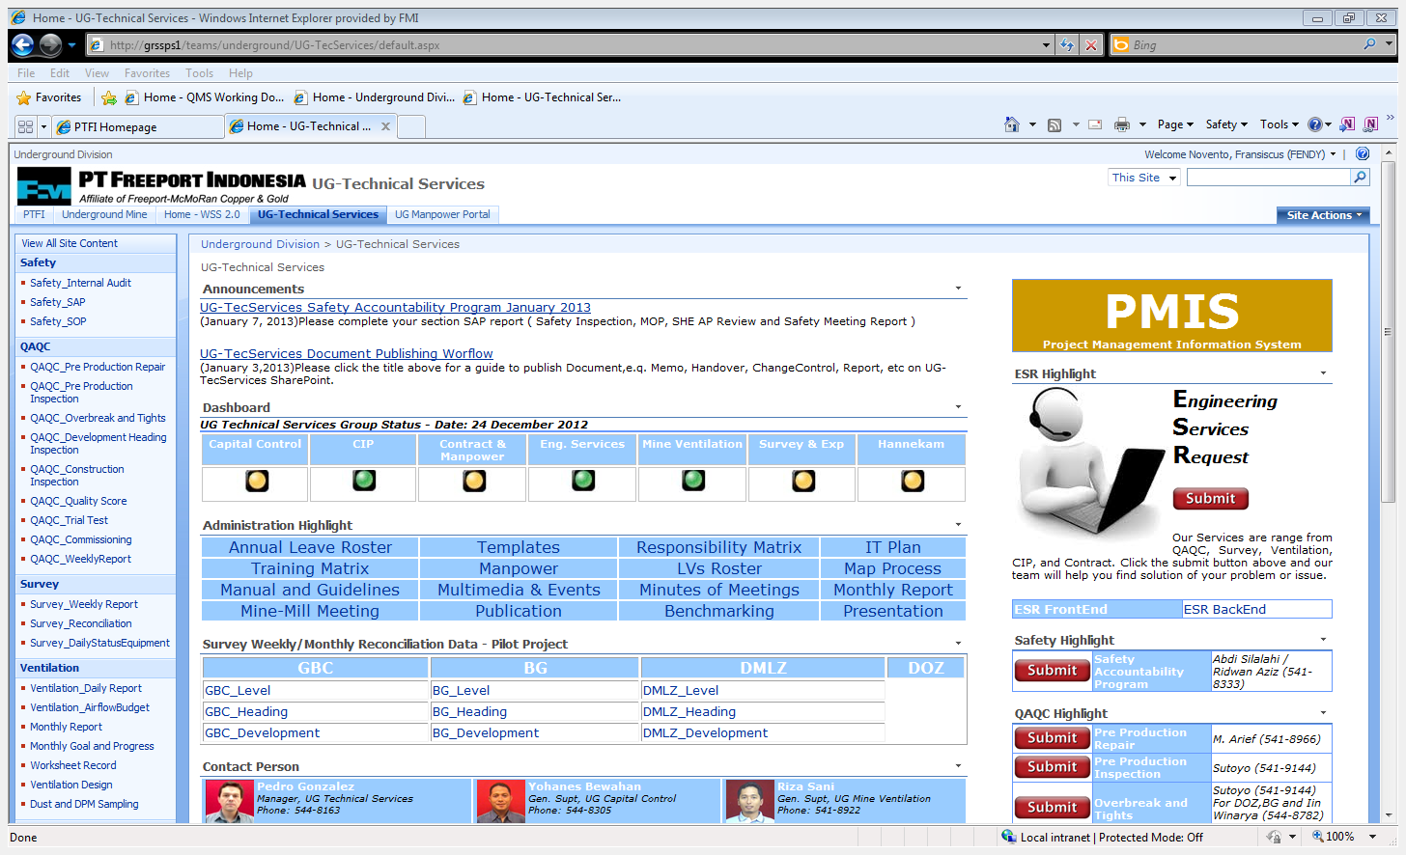
UG Technical Services as an organization realize those issues above and beginning to use SharePoint as collaboration tools to centralize all the data and information on a single web portal.

The following processes were identified and translated into SharePoint solution:
- Document management
- Communication – Publication
- Dashboard reporting
- Field Inspection Data
- Safety Accountability Data
- Safety Internal Audit
- Discussion Board
- Helpdesk Request Recording
- PMIS

Document Management
Storing Document on network based storage is heavily cluttered and difficult to explore. SharePoint document library offer much control and easy to explore because it has a web based interface. The controlling feature has the following output:
- Historical information where we could restore the previous documents
- Versioning information with major and minor version
- Authoring with some access privilege, i.e. read only, contributor
- Grouping where we could group documents based on meta data ( category )
- Controlling with check in / out feature for document integrity

Communication – Publication

Communication and Publication is one of the significant issues for UG Technical Services. E-mail was the primary tools for its purpose. However, using email as storage is not the best solution, For instance it takes times to find certain file or subject on inbox. SharePoint Announcement was used to replace this behavior. All the information was published not only from email but also on SharePoint Announcement on SharePoint portal. Everyone can have a look and search for the publication history within period of time.

Dashboard Reporting

The concept of Dashboard Reporting has been emerged since the release of Excel spreadsheet chart and tables. WSS 3.0 does not support Dashboard Reporting, however with the chart that been made in Excel can be save and publish as a web page that can be displayed on SharePoint portal.

Field Inspection Data

The field inspection data on Survey, Ventilation and QAQC plays important roles in operation work. The inspection result was submitted via SharePoint custom list on portal by engineer, then following PDCA ( Plan Do Check Action ) process on ISO 90012008 the chief engineer/Supt/Gen. Supt need to check for outstanding issues the make an analysis report. Every inspection result will have Open and Closed Status with its priorities.

Safety Accountability Data
UG Technical Services group member has a mandatory task to submit their Safety Accountability every month, e.g. Safety Inspection, Plan Job Observation, etc. The document was submitted through SharePoint portal then Safety Admin office will review and validate the finding issue, report to management and come up with follow up action for outstanding issue.

Safety Internal Audit
Internal Audit was conducted by Safety Group on daily basis for Quality Control of Safety implant inside organization. SharePoint Custom List recording the finding audit then safety admin officer will validate and review the finding, assigned the issue to area owner, track the progress until they are resolved then report to management.

Discussion Board
Discussion about certain topic or issue was usually conducted through email that will have an impact on email performance and un-traceable. SharePoint Discussion Board work as a web discussion board where each member of the group can share and comment ideas from the web. The Discussion result can be view and traceable for further action to follow up.

Helpdesk Request Recording
Helpdesk ticket was a well knows system for recording and tracking request. Engineering and Non-Engineering request for conducting job or task usually conducted by e-mail or phone that will impact on lost track and history. SharePoint Custom List can be modified to accommodate a simple Helpdesk system throughout organization. User or stakeholder submit their request from SharePoint portal , SharePoint administrator will assign the task to the appropriate person, the assigned person can update the progress online from the portal then mark resolved or closed when completed. SharePoint administrator will create a weekly / monthly report to management about outstanding ticket and find solution to close the ticket.

PMIS
Project Management Information System (PMIS) plays significant roles in Project Management Methodologies and Practice. Dedicated Software such as Primavera, Project Professional 2010, etc has been made to accommodate the business needs from users. UG Technical Services group members don’t have a standardized templates or methodology in terms of Project Management. Basic Project Management methodology training and PMP certified is perquisite for using such tools. UG Tec Services utilize SharePoint for PMIS with emphasis on Standardized Project Management Process according to PMBOK (Project Management Book of Knowledge) 4th Edition by ww.pmi.org.

Conclusions
SharePoint implementation on UG Technical Services has proven to be effective tools for collaboration and document management. The implementation from collecting, creating, socialization, and training for group members has been successful with some notes for improvement. Feedback has been rolled out on daily basis for corrective action and improvement. The upcoming challenge that UG Technical Services will need to pursue are recognition of ISO 9001:2008 and Project Management Methodology certification.

References
Raymon, Dux, (2012), SharePoint 2010 for Project Management, Second Edition, O’Reilly Media Inc.
ISO, (2008), ISO 9001:2008 Quality Management System – Requirements, ISO 2008
Institute, Project Management, (2008), A Guide to the Project Management Body of Knowledge, Project Management Institute Inc.

